Carlisle County ANR
Newsletter January 2023 2017

Cooperative Extension Service
Carlisle County
65 John Roberts Road
Bardwell, KY 42023-0518
(270) 628-5458
Fax: (270) 628-3722
extension.ca.uky.edu

Dates to Remember:
Winter Wheat Meeting –Jan 5, 2023-Flyer attached-Hopkinsville
KY Commodity Conference-Jan. 19, 2023-Bowling Green
Soybean Promotion Day-Jan. 23, 2023-Murray State
WAVE AG Partnership Luncheon-Feb. 2, 2023-Young Center-Clinton
Winter Ag Conference- Feb. 10, 2023-Lowry Farm
Pesticide Training Dates-flyer attached
UKY Corn, Soybean, Tobacco Field Day-July 25

Save the Date-Feb. 2, 2023
WAVE AG Partnership/Farmers Luncheon
Young Center
Clinton, KY
11:30 a.m.

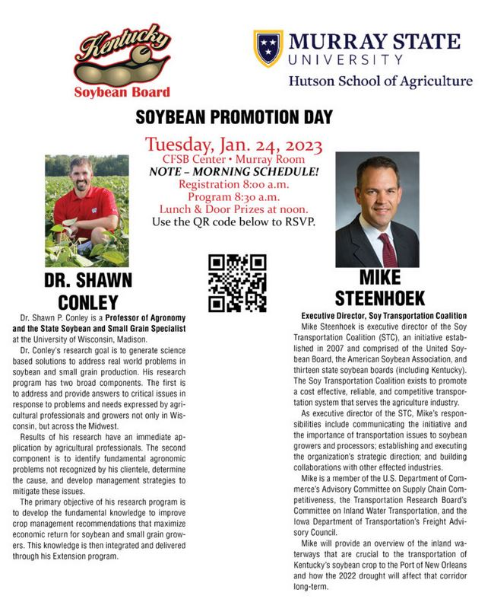
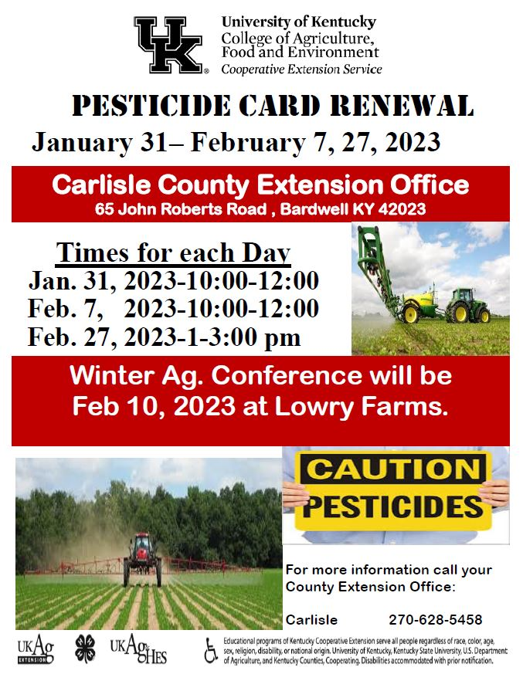

Choosing Tomato Plants with Disease Resistance
Professional tomato growers are very conscious of the diseases that are likely to affect their plants. If growing outside each season, and in the same soil, a grower will have a good idea “what lurks beneath!” and how to combat it.
However, for the home gardener, a little understanding of diseases and how to avoid them will go a long way.
There are many diseases that affect tomato plants, but here are some very common ones:
Verticillium Wilt, Fusarium Wilt, Nematodes
Disease resistant codes such as VFN = Verticillium Wilt, Fusarium Wilt and Nematodes are often mentioned or listed on seed packets – Roma VF for example
The two wilts (V+F) are fungal diseases that stop-up a plant’s plumbing. Nematodes (N) are microscopic worms that attack roots, and again, effect a plant’s plumbing by restricting water and nutrient absorption by the roots.
Blight tolerant varieties – blight is a most serious fungal disease as it spreads easily and can destroy all your plants in a couple of weeks! Legend, Ferline F1 and Losetto F1 are blight tolerant and put-up some resistance – but they are not immune.
The new Crimson Crush and Mountain Magic varieties are blight resistant and their fruit can escape blight – even in a warm wet July and August!
Choose plants with vigorous growth
A healthy, quick growing tomato plant may not be immune to disease but will be able to last longer before being effected and often produce ripe fruit before being “bumped off!”.

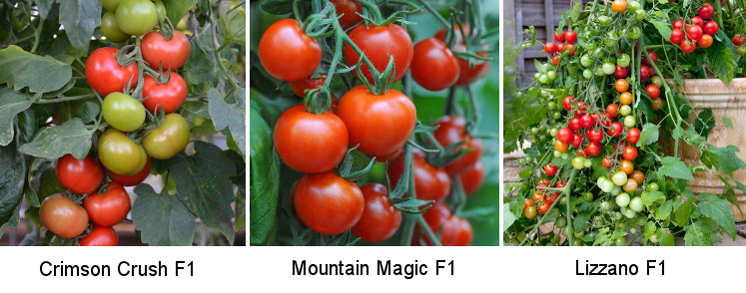
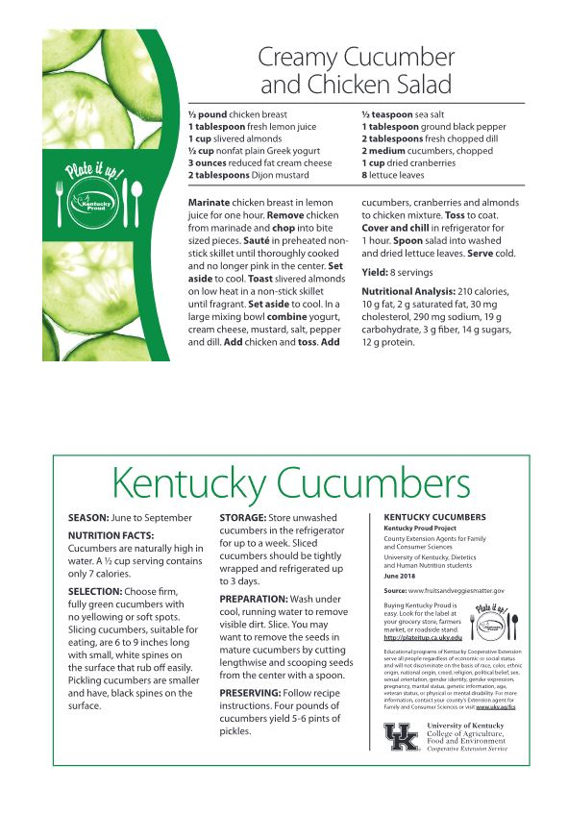

Information released by
Chuck Flowers
Carlisle County Extension Agent
Agriculture & Natural Resources/4-H

Carlisle County
P O Box 518
Bardwell, KY, 42023-0518

RETURN SERVICE REQUESTED

